Subject Definition Analysis 2

Michelle Caples
INFOST 650G-201- An Introduction to Modern Archives Administration
December 9, 2024

Digital preservation is fraught with many challenges for an archivist. Two predominate challenges in digital preservation are preservation principles, and copyright. One could argue that the same principles for analog preservation can apply to digital preservation. In a sense this is true, but digital preservation also encompasses technology which can lead to an archivist having to sort out copyright issues, At this point, different guidelines must be created and followed when it comes to digital preservation.

“The fundamental principles of preservation in the digital world are the same as those of the analog world and, in essence, define the priorities for extending the useful life of information resources. These fundamental concepts are longevity, choice, quality, integrity, and access” However, another aspect that must be considered with digital preservation is the user. The article The Old Version Flickers More”: Digital Preservation from the
User’s Perspective states “First, our primary interest was to learn about digital preservation from the user’s perspective. We wanted to understand which features users consider worth preserving, rather than what archivists believe is important or what theoretical models would predict.”

An archivist must sort out what is fundamental to the collection, what materials will last the longest, and what materials will be sought out by and beneficial to a user of a collection in the future. Technology will play a significant role into the development and preservation of a digital collection. Let’s look at two graphs from the article Digital Processing: Exploring the Enigma
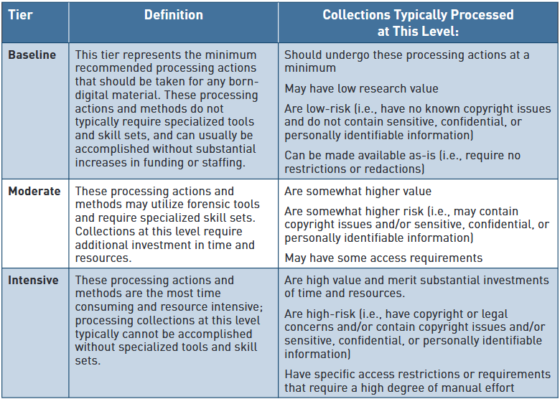
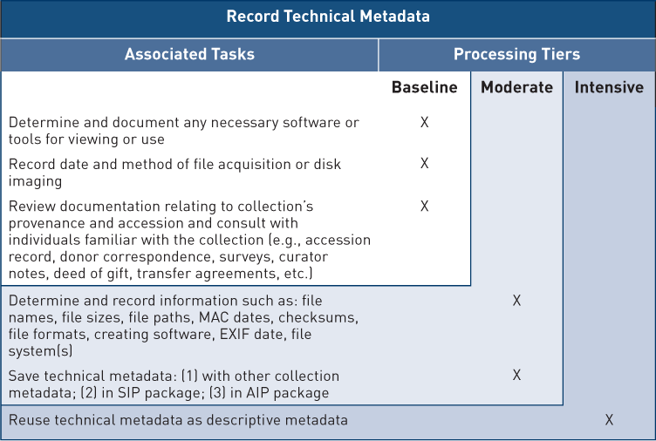

Graph 1 is interesting because it lays out processing actions and mentions copyright issues that may arise. This starting point of digital preservation reflects the principals found in analog preservation, but takes into consideration file names, sizes, paths, formats, creating software, and technical metadata. Once can see donor correspondence, accession records, and provenance still are terms found in analog preservation. Reuse of technical metadata as descriptive metadata is the sole proprietor of the intensive processing tier on the graphic. What exactly is digital processing? “Defining the scope of digital processing is critical for clear communication across the profession; tensions are ongoing between minimal processing and digital preservation; the seismic shift from analog to digital archival processing has created confusion in terminology that leans on technological implementations; and the professional intersection between digital preservation and archival activities requires careful negotiation”.
In the article Mapping the Preservation Landscape for the Twenty-First Century defines digital preservation as, Instead of the word preservation, we are now likely to use curation and stewardship, terms that are relatively free from the association of preservation with physical objects. Curation and stewardship allow a wider view of preservation, as something more than a set of technical processes isolated from services, policies, and stakeholders, that also takes account of a wide range of stakeholders cutting across disciplinary boundaries—libraries, archives, and museums, and also funding agencies, government bodies, national datacenters, institutional repositories, and learned societies.
Now that the definition of digital preservation has been established, how does definition and practice impact users? That depends on how users value archives. In the article Perceptions and Understandings of Archives in the Digital Age, the author states the findings of a survey from users:
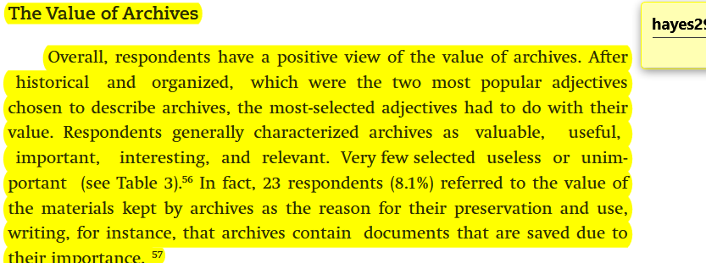

How information is accessed and who it belongs to is something a user will never have to think about, abut an archivist will. Copyright is part of the digital preservation landscape. The article Legal and Ethical Considerations for Providing Access to Born-Digital Collections: Copyright
provides this overview about copyright:
Copyright in the United States is defined as, “A form of protection provided by the laws of the United States for “original works of authorship”… “Copyright” literally means the right to copy but has come to mean that body of exclusive rights granted by law to copyright owners for protection of their work” (U.S. Copyright Office).
Archives are filled with copyrighted materials, and Archivists have been providing access to them for years. So what is different about born-digital archives, and what do we need to consider when providing access to them?
The method of access is unique to digital content. Namely that it must be rendered using a machine, and this machine rendering requires multiple copies to be made. Section 108 of the US Copyright Statute authorizes libraries and archives to make copies for preservation and access purposes, but there are limitations to this provision that have serious legal consequences for born-digital access.
The access affordances that are unique to digital content. It can be reproduced and distributed online more easily than physical material, and therefore has the potential to reach a wide public audience. If made openly available online without clearly articulated access, use, and takedown policies, this level of visibility increases the likelihood that a copyright holder will challenge the repository (Hirtle 2015, 2).
The scope of copyrighted material that is unique to born-digital collections. Like most archival collections, modern born-digital collections often largely comprise unpublished material. Additionally, they are usually sizable, and are likely to contain works by more creators than physical collections, which is particularly true for collections containing email. Donors can only transfer copyright or license use of the email messages they authored, not the messages they received. Thus, it is reasonable to expect an email archive to contain copyrighted materials from hundreds or thousands of authors (Briston 2015, 26). This presents a logistical challenge for institutions seeking to provide online public access to this material.

What should the archivist do? The article states the activist should do the following when it comes to copyright in a digital collection.
Document copyright ownership during the acquisition or accessioning phase. While it is not the Archivist’s responsibility to research and identify the copyright holder on behalf of the user and/or determine if their use violates copyright law, documenting the copyright owner supports use of collection material by both the user and the institution.
Undertake a fair use assessment before making born-digital records available online. Does copyright law impact your ability to reproduce and provide access to it under fair use? Maintain documentation of this assessment.
Maintain consistent documentation of the research, reasoning, and justification behind decisions to make born-digital content available in the specific way it is made available, such as via a publicly accessible online platform. Documentation demonstrates diligence of the investigation and helps to support the fair use determination if it is called into question.
Consider your resources and plan strategically. If making born-digital records available online, it is necessary to carefully consider the immense amount of labor typically required to research copyright status and owner, obtain authorization to publish (if necessary), and create item-level metadata as it pertains to copyright.
This ties into outreach and the role users feel archives should play in their lives. In Patterson’s article Perceptions and Understandings of Articles in the Digital Age, a study of the users and their perception of the value of archives found the following:
The Value of Archives
Overall, respondents have a positive view of the value of archives. After “historical” and “organized,” which were the two most popular adjectives chosen to describe archives, the most-selected adjectives had to do with their value. Respondents generally characterized archives as “valuable,” “useful,” important,” “interesting,” and “relevant.” Very few selected “useless” or “unimportant” (see Table 3).56 In fact, 23 respondents (8.1%) referred to the value of the materials kept by archives as the reason for their preservation and use, writing, for instance, that archives contain “documents that are saved due to their importance.”
In conclusion, digital archives and the role of the archivist will continue to evolve. Archivists are in a good position to manage digital preservation due to guidelines and research being done by the MLIS community. Copyright guidelines will continue to be fluid, however if an archivist can rely on basic guidelines for digital preservation they can achieve their goals of providing a good, ethical collection to users.

Bibliography
Fauldner, Erin, Jackson Laura Uglean. 2022. The American Archivist. July 1. Accessed December 9, 2024. https://meridian-allenpress-com.ezproxy.lib.uwm.edu/american-archivist/article/85/1/146/483440/Digital-Processing-Exploring-the-Enigma.
Harvey, Ross, Mahard, Martha. 2013. "Mapping the Preservation Landscape for the Twenty-First Century." Preservation, Digitial Technology and Culture 42, no 1 5-16.
Hedstron, Margaret, Christopher Lee, Judith Olson, and Clifford Lampe. 2006. "The Old Version Flickers More”: Digital Preservation from the User's Perspective." The American Archivist, 69, no 1 159-187.
Patterson, Caitlin. 2016. "Perceptions and Understandings of Archives in the Digital Age." The American Archivist 79, no 2 339-370.
Schechter, Gayle. 2023. DLF. January 13. Accessed December 9, 2024. https://www.diglib.org/legal-and-ethical-considerations-for-providing-access-to-born-digital-collections-copyright/.

Harvey, et al. “Mapping the Preservation Landscape for the Twenty-First Century,” 9
Hedstrom, et al. “The Old Version Flickers More”: Digital Preservation from the User’s Perspective,” 160
Fauldner, et al.” Digital Processing: Exploring the Enigma,” 157 and 159
Fauldner, et al.” Digital Processing: Exploring the Enigma,” 162
Harvey, et al. “Mapping the Preservation Landscape for the Twenty-First Century,” 6
Patterson, “Perceptions and Understandings of Archives in the Digital Age”, 360
Schechter, Legal and Ethical Considerations for Providing Access to Born-Digital Collections: Copyright 1

