**What goes in the HEAD portion of the HTML document**

I found a helpful YouTube video that answers this question. I provided a summary of the key concepts of the video below and a link to the video.

The following components make up the Head portion of the HTML document:

* Title Tag: Title tag of webpage important for SEO and user experience. The title tag can only be used one time.
* Style Tag: Uses CSS styling added in HTML documenta
* Link Tag: Connect external CSS style to HTML document
* Meta Tags: Provides metadata for HTML documents. Can have multiple occurrences.
* Script Tag: Used to include reference to external java script code in HTML document
* Base Tag: Specific URL- Can only have one base element in a document.

Train To Code. (2023, September 29). *Every HTML head tag explained* [Video]. YouTube. <https://www.youtube.com/watch?v=_LrggW9Ra1Y>

[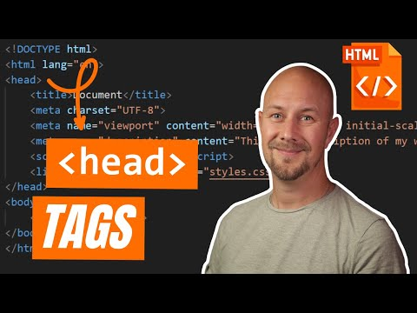](https://www.youtube.com/watch?v=_LrggW9Ra1Y)