Fonts are expressed in HTML by use of the font family property. The **font-family** [CSS](https://developer.mozilla.org/en-US/docs/Web/CSS) property specifies a prioritized list of one or more font family names and/or generic family names for the selected element. The choice of font is based on the system a website is running on if using the font family. However, CSS allows a website developer to specify a font file from the web that downloads as the website is accessed.

There are five basic types of CSS families of fonts: serif, sans serif, cursive, fantasy, and monospace that a developer can specify for use on their website. Web safe fonts include aria, Helvetica, Georgia, Times New Roman, New Courier. A generic option should always be available because there is no guarantee a font will be available.

Below are links with CSS styling.

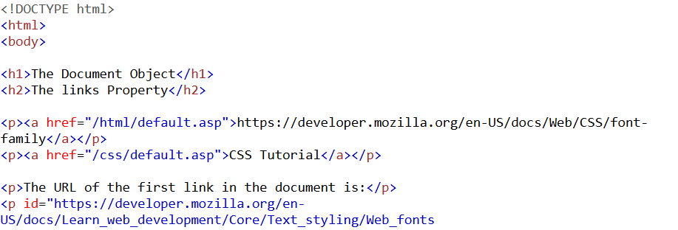

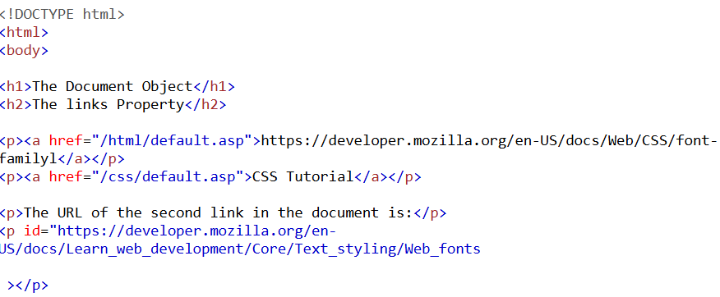

References:

font-family - CSS: Cascading Style Sheets | MDN. (2025, February 4). MDN Web Docs. <https://developer.mozilla.org/en-US/docs/Web/CSS/font-family>

*Web fonts - Learn web development | MDN*. (2025, January 27). MDN Web Docs. <https://developer.mozilla.org/en-US/docs/Learn_web_development/Core/Text_styling/Web_fonts>